[Table of Contents]
Project Features 2
1. AI Chatbots for Continuous Feedback: Enhancing Employee Insights (e.g. job satisfaction) 2
1.1. Business Process 1 2
1.1.1. Use Cases 2
1.1.2. Business Process Diagram (BPMN) 4
1.1.3. User Stories 4
Field Requirements / Business Rules 5
Wireframe 5
Test Cases 5

Project Features

AI in Accounts Payable

Artificial Intelligence in Accounts Payable focuses on improving the efficiency, accuracy, and automation of accounts payable processes through the use of AI technologies such as Machine Learning (ML), Natural Language Processing (NLP), and Robotic Process Automation (RPA). The system is designed to reduce manual effort, minimize errors, improve payment accuracy and support faster financial workflows while maintaining human oversight for approvals and exception handling. The features in my prototype is focused on automating key accounts payable activities including: Goods Receiving Confirmation , Invoice Data Extraction , Invoice Data Matching , Payment Processing and its Bank Verification and Accounting Records Updating.

Business Process
Accounts Payable Process begins when a department identifies the need for goods or services. A purchase order is then created containing product descriptions, quantities, delivery details and pricing information. After supplier shipment, the warehouse receives the goods and verifies whether the delivered items match the purchase order. AI-supported automation helps confirm deliveries and identify mismatches. The invoice is then received digitally, usually through email , electronic invoicing or by scanning and uploading the invoice. NLP and ML technologies automatically extract invoice information, reducing manual data entry. The accountant verifies supplier information, banking details, purchase order references and invoice accuracy. AI assists by comparing invoices with purchase orders and goods receipts to detect discrepancies such as duplicate invoices or incorrect amounts. If discrepancies are identified, the process moves to re-checking with the supplier until the issue is resolved.

Once validated, the invoice goes through approval procedures. AI supports this process by identifying invoices that require managerial review based on amount, supplier risk or exceptions.After approval, payment processing occurs using AI-supported RPA and ML technologies. The system assigns ledger accounts, validates tax codes, schedules payments and checks due dates. The system then verifies payment success with the bank. If payment fails, the process routes to bank checking and retry procedures. After successful payment, the system automatically updates accounts payable ledgers, general ledger record, and supplier balances. Finally, invoice documentation is archived digitally for transparency, auditing and future retrieval.

Use Cases
[Provide a use-case diagram that shows the proper use of business process] Use: Draw.io
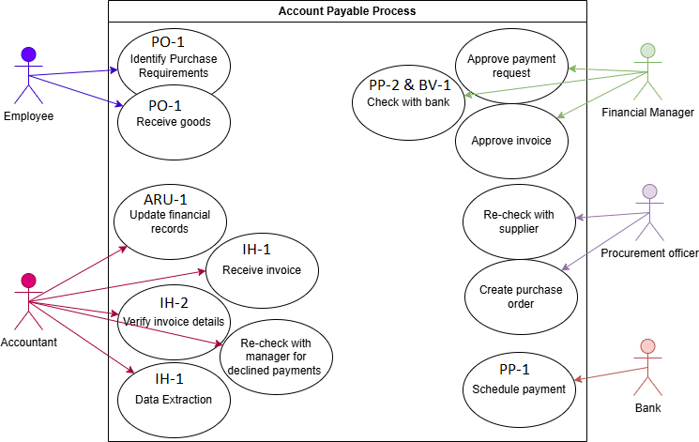

Business Process Diagram (BPMN)
[Provide a BPMN that helps you visualize your conceptual framework]
Use: https://camunda.com/
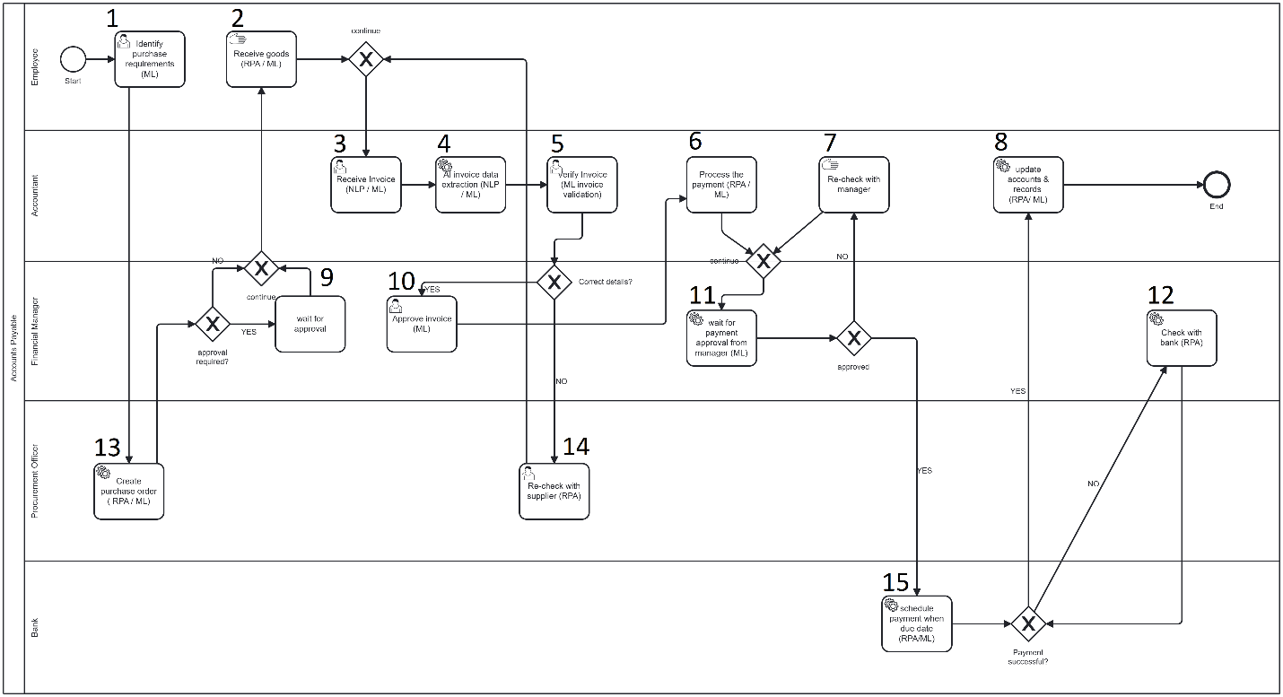

User Stories
[Create some user stories and split the business process into different epics to dive narrower into context]

Requirement ID | Epic | User Story Summary
PO-1 | Receiving Order | As an employee, I want AI(RPA/ML[Unsupervised ML] ) to automatically confirm delivery once goods are received so that payment and accounting processes can continue accurately.
IH-1 | Invoice Handling | As an accountant, I want AI (NLP) to extract invoice data automatically so that manual data entry is minimized.
IH-2 | Invoice Handling | As an accountant, I want AI (ML[Supervised learning (classification)]) to verify invoice details against the purchase order and goods receipt so that discrepancies are identified early
PP-1 | Payment Processing | As an accountant, I want AI (ML[Supervised learning (classification)])to determine whether a payment requires managerial approval so that financial risks are minimized.
PP-2 | Payment Processing | As the system, I want to schedule payments for their due dates using AI (RPA) so that cash flow is optimized.
BV-1 | Bank Validation | As an accountant, I want to confirm payment success with the bank (RPA) so that any failed transactions are detected promptly
ARU-1 | Account Records Update | As an accountant, I want AI (RPA) to automatically update financial records after payment so that accounting data remains accurate and current.

Field Requirements / Business Rules
[Provide some fields that shows up on the interface, and some business rules that limits the use within the product]
Fields | Fields Description
Purchase Order ID | The unique id for each purchase order that is being filled and will be ordered.
Created | The date the purchase order is created.
Items | The item names that are ordered.
Amount | The price of the purchased order.
Invoice Number | The id of the invoice received.
Supplier | Name of the supplier that we ordered from.
Goods Received | The id of the goods received.
Invoice Date | The date the invoice was created.
Due Date | The date the supplier must be paid.
Tax Amount | The amount of taxes on this invoice.
Scheduled Date | The date we schedule to pay the suppliers for a specific invoice.
Payment ID | The id of the payment done.
Category | Which category is this invoice to be updated in the accounting books.
Total Ordered | The total price of everything ordered from a specific supplier.
Total Invoiced | The total price of every invoice received from a specific supplier.
Total Paid | The total paid amount of orders from a specific supplier.
Outstanding Balance | The total unpaid amount of orders from a specific sup plier.

Rule ID | User-Story ID | Fields | Business Rule
BR-01 | PO-1 and IH-2 | Purchase Order ID, Items, Goods Received | Goods receipt must be recorded before confirmation AI can auto-confirm only if: 1. Quantity received = quantity ordered 2. No damage/exception is reported. Each receipt must be linked to a valid PO.
BR-02 | IH-2 | Items, Goods Received, Amount | Invoice must be matched with: Purchase Order , Goods Received and Amount. If mismatch detected then flag as exception
BR-03 | PP-1 and BV-1 | Payment ID, Due Date, Scheduled Date | Payment must be scheduled on or before due date and No duplicate scheduling for same invoice. System must reschedule failed or missed payments
BR-04 | BV-1 | Scheduled Date, Payment ID | Payment confirmation must be retrieved from bank system. If bank response = failed: Payment status = Failed and Retry process All bank interactions must be logged
BR-05 | ARU-1 | Category, Total Ordered, Total Invoiced, Total Paid | Financial records updated only after payment confirmation  Updates must include: Ledger entries and Vendor balance  Double-entry accounting must be enforced. Failed payments must not update records. All updates must be timestamped and auditable.

Wireframe
https://www.figma.com/make/UIv2N5a1blew8YZLS6PaUT/Procurement-andInvoice-Automation?t=zvrvI88yE46aYlHX-1&preview-route=%2Faccounting

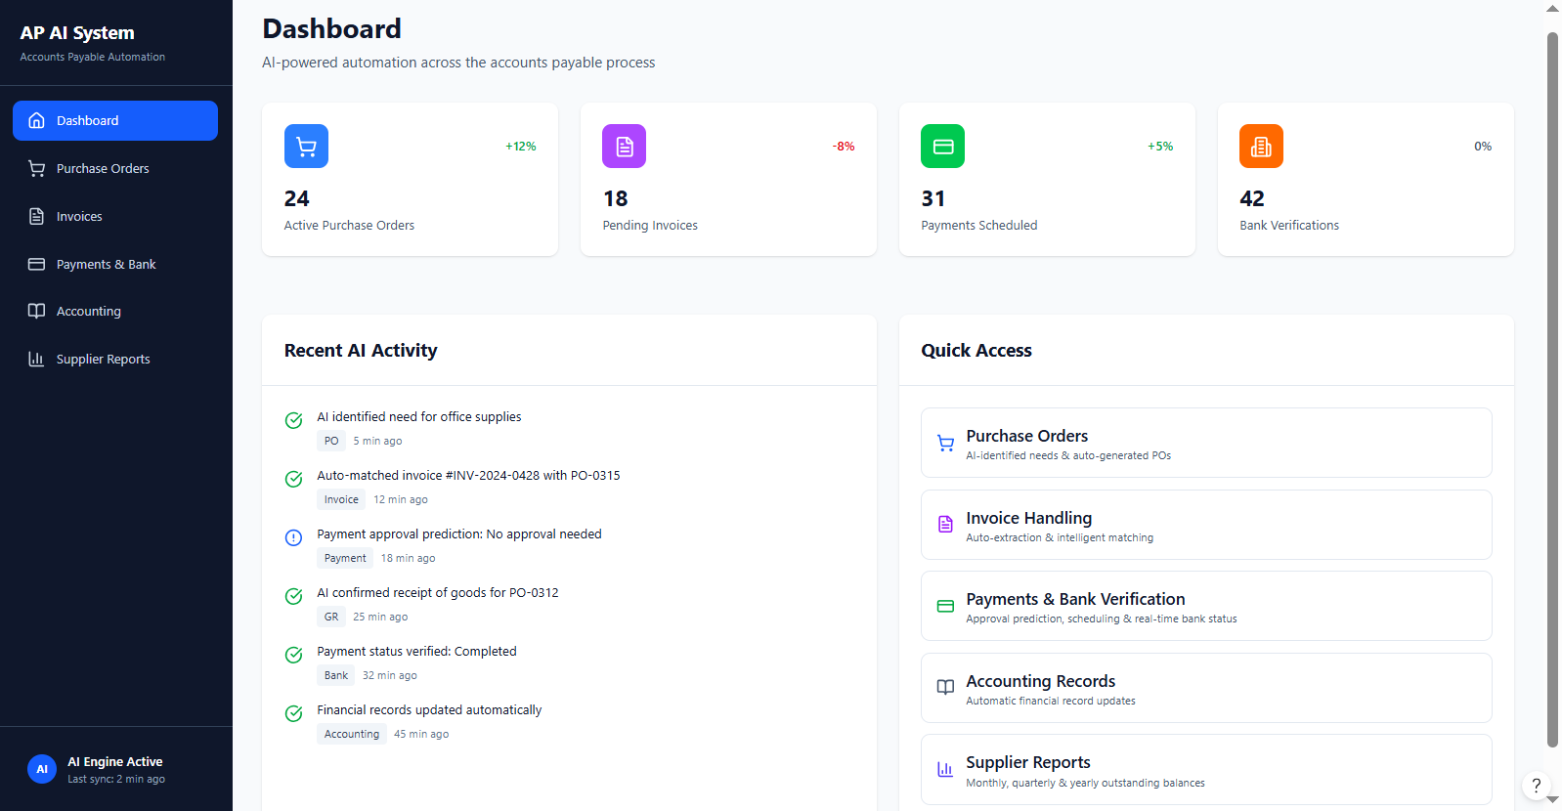

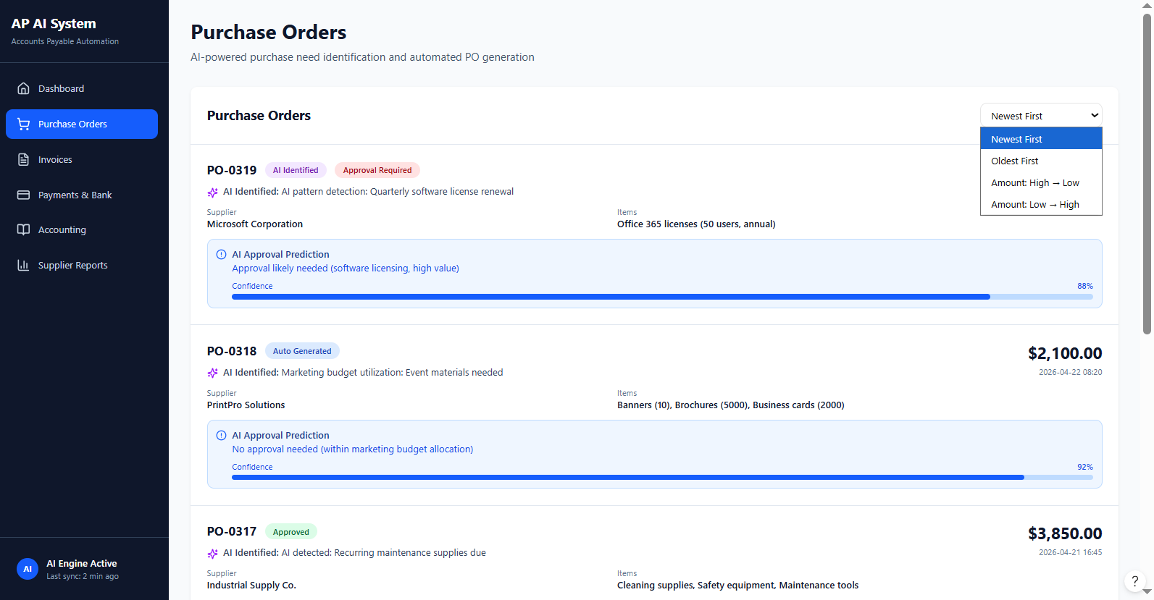

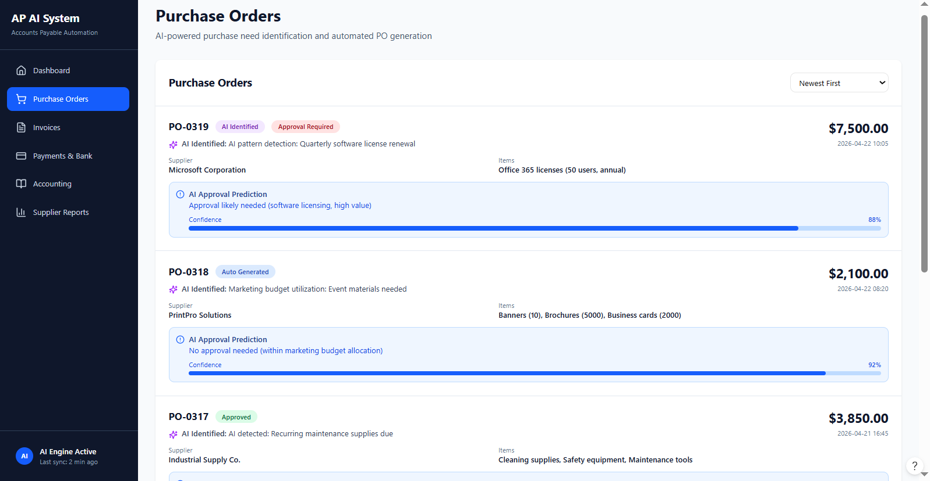

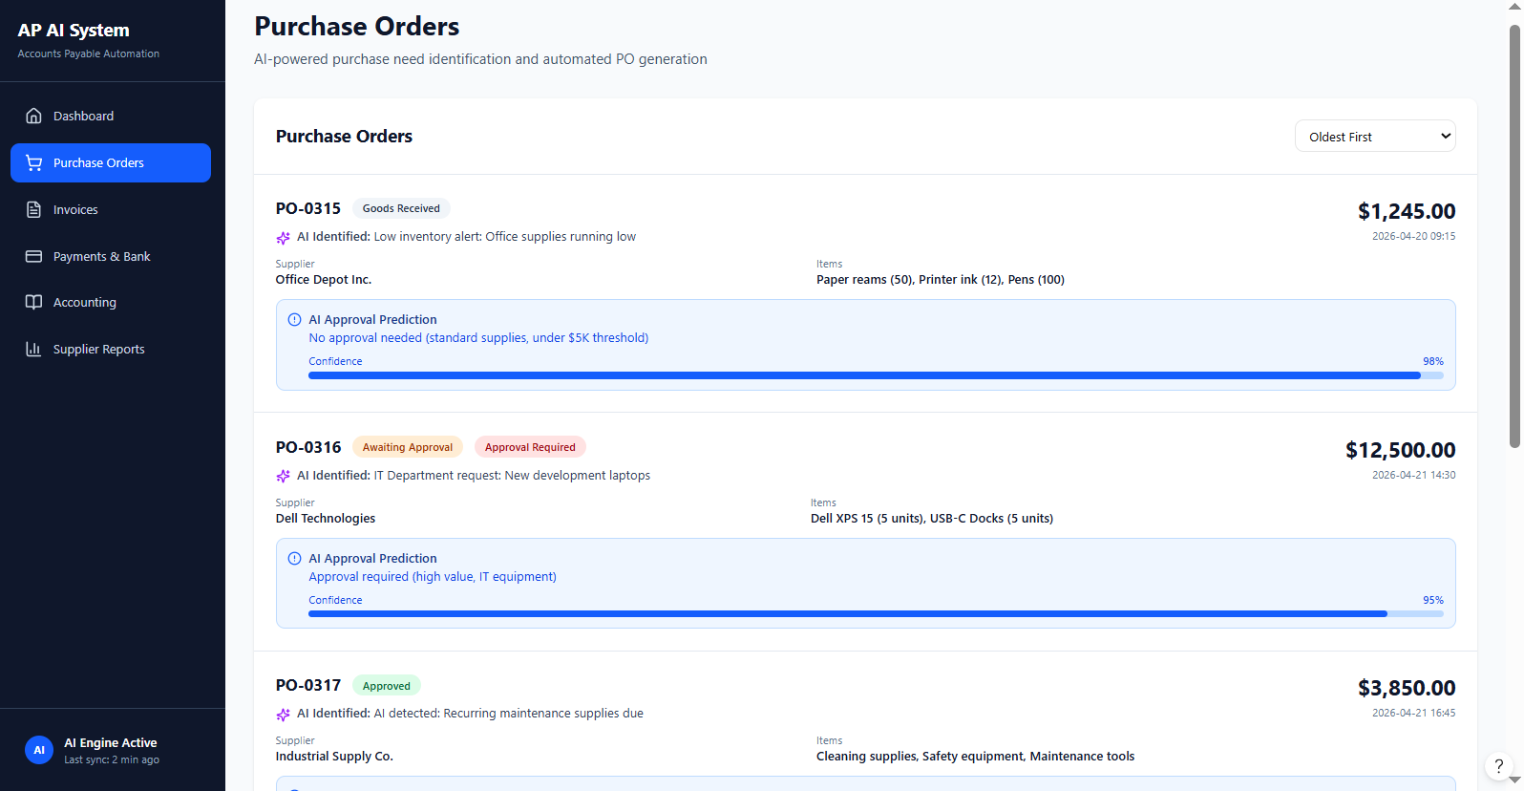
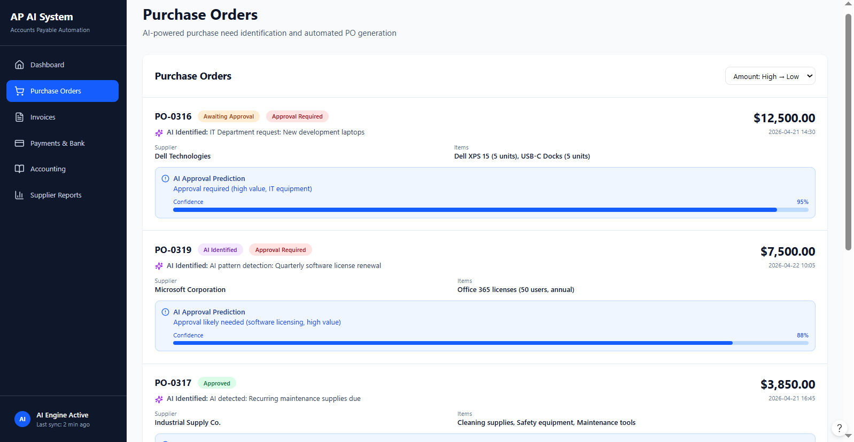

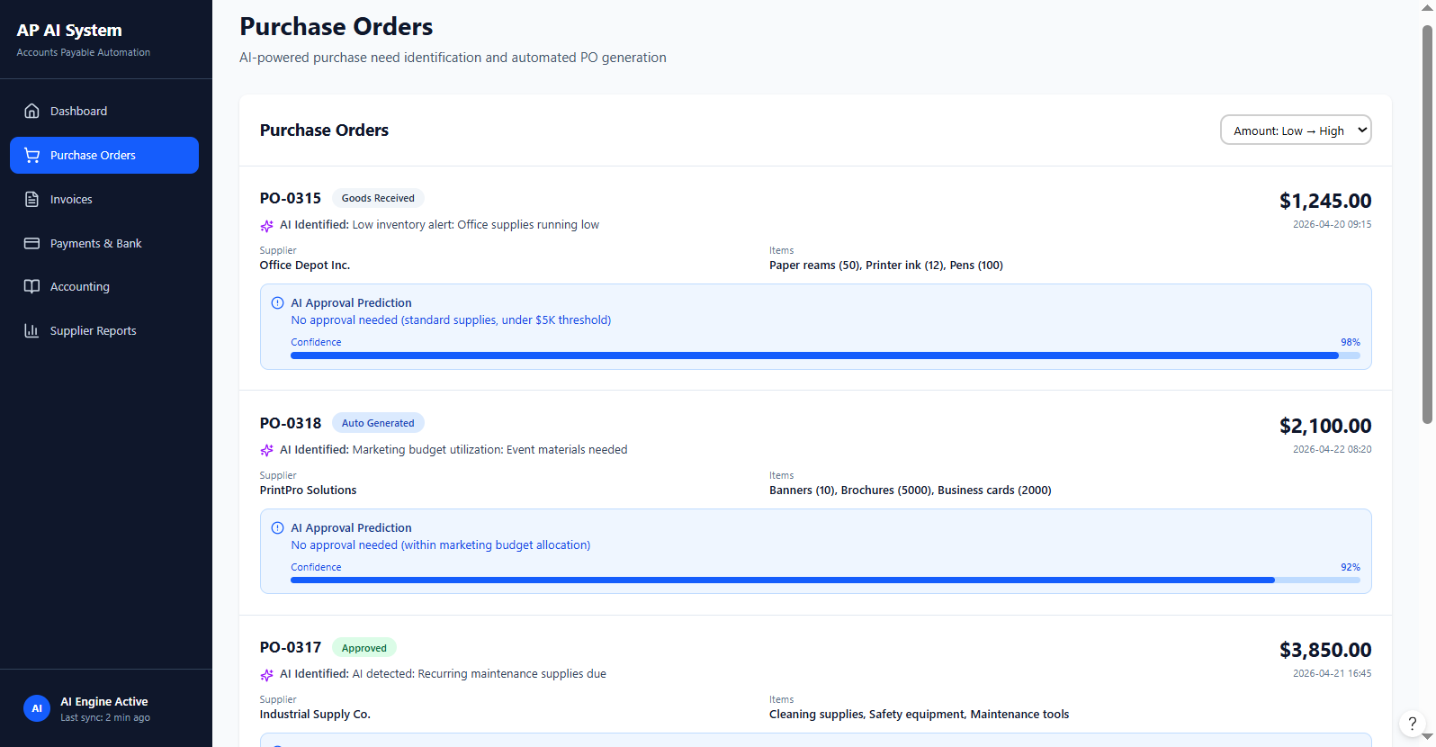

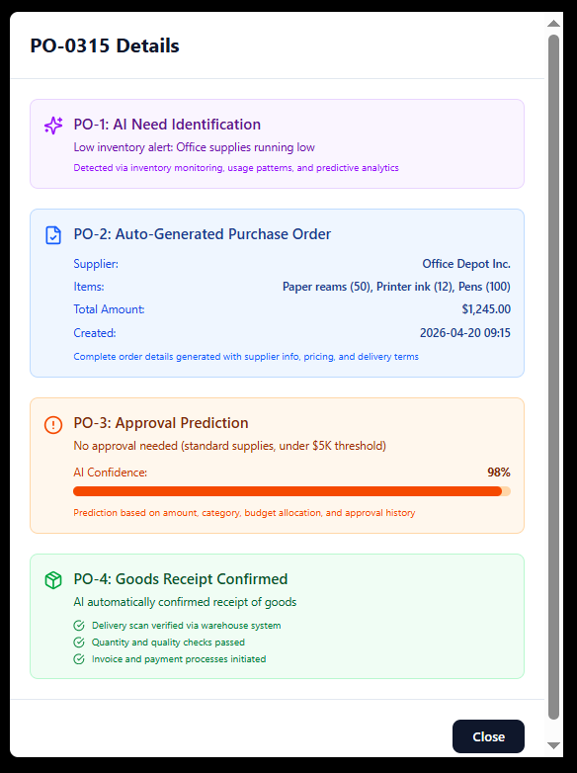

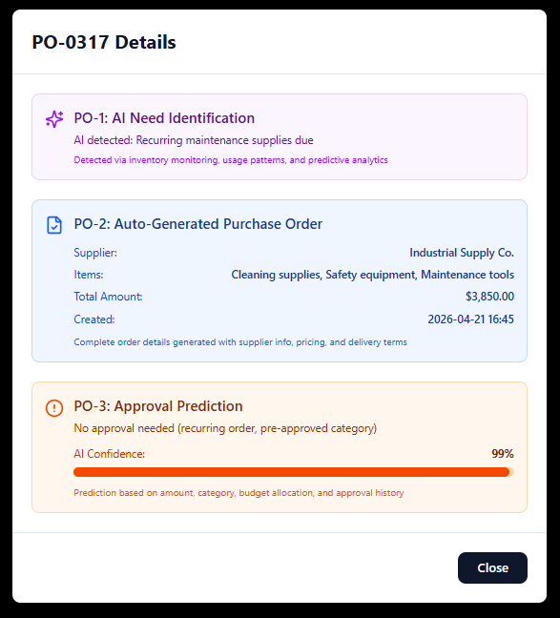

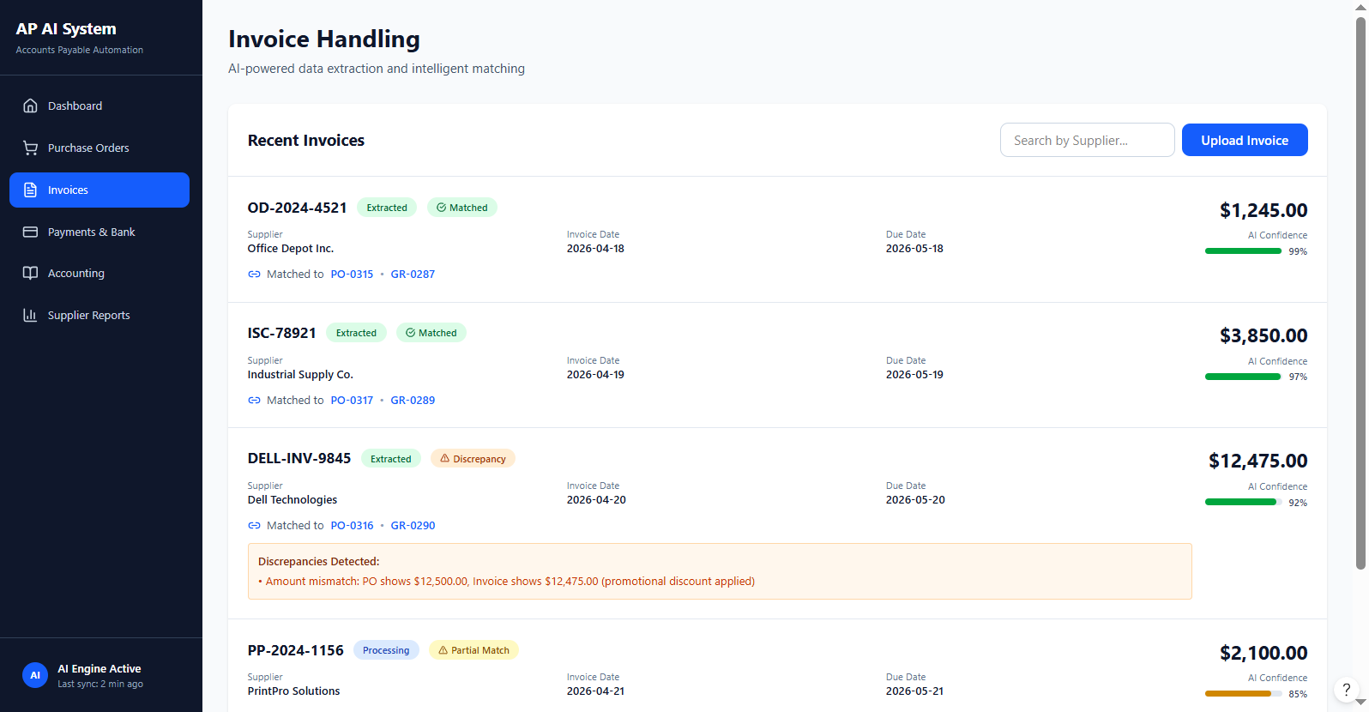

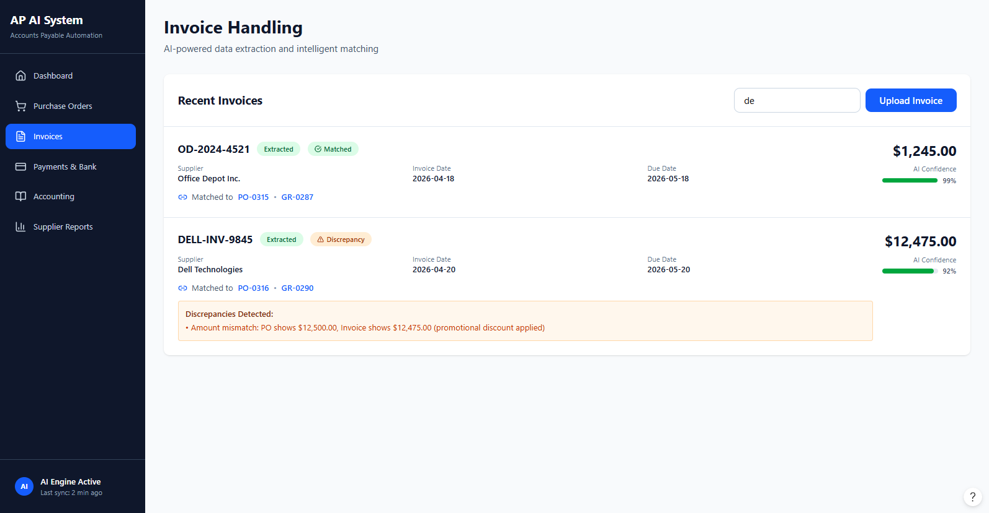

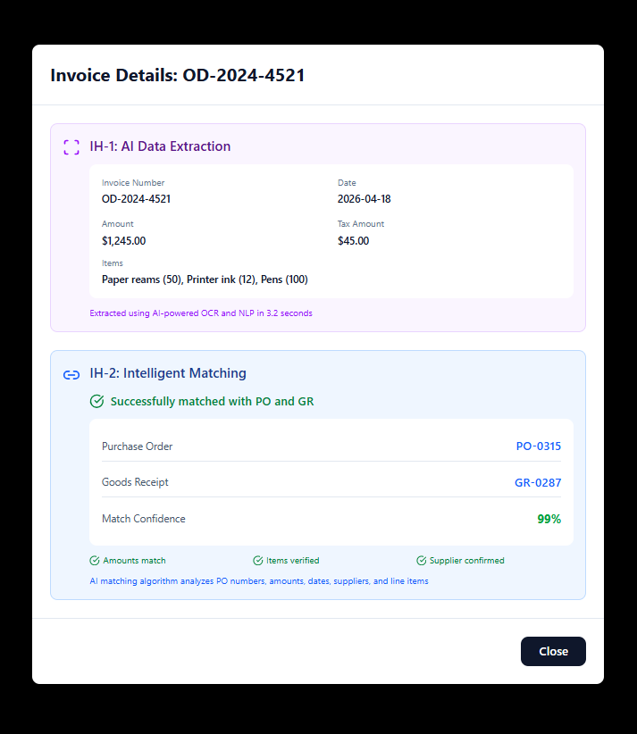

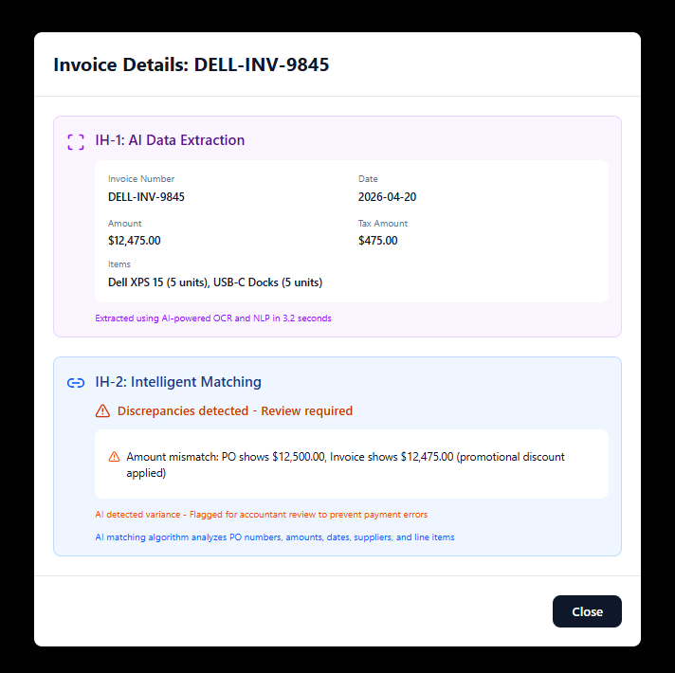

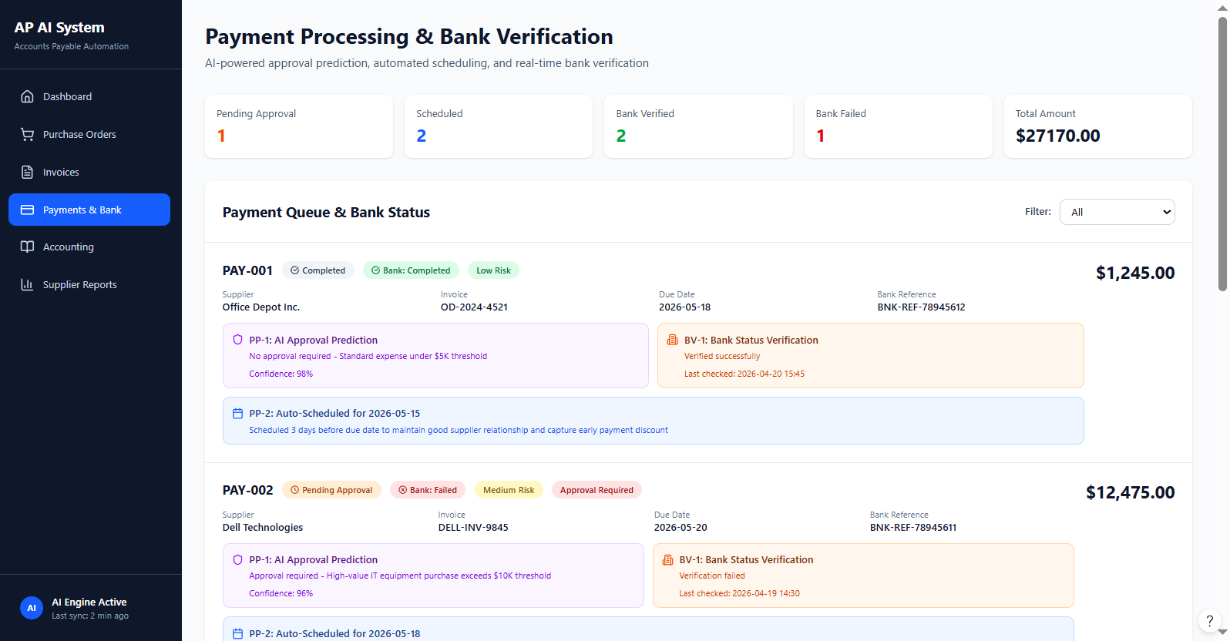

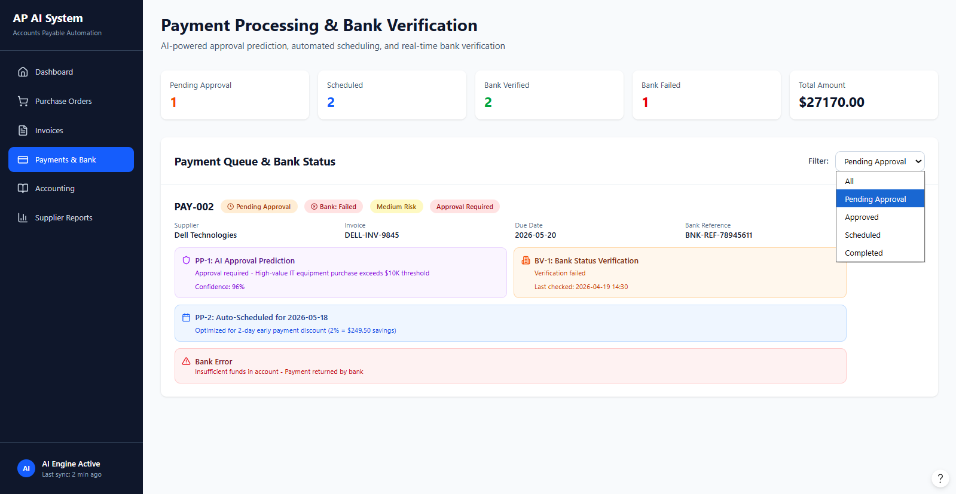

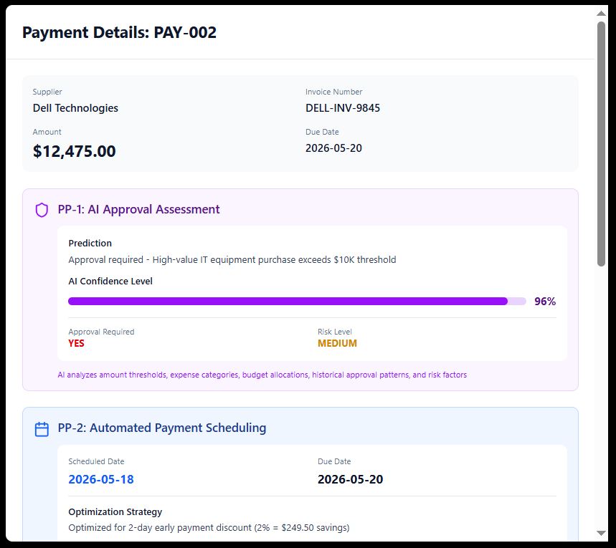

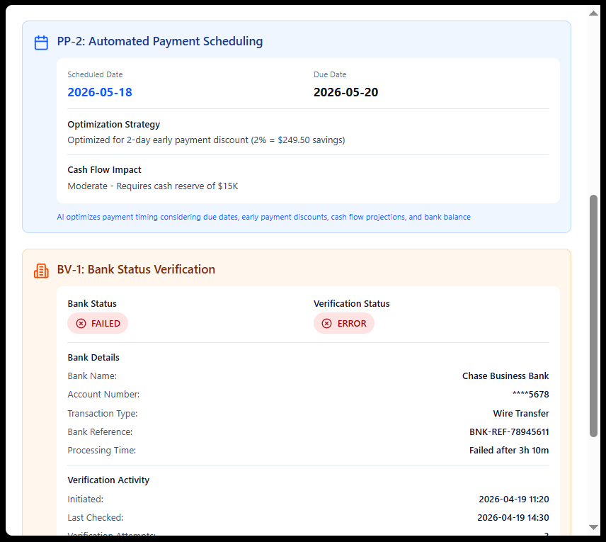

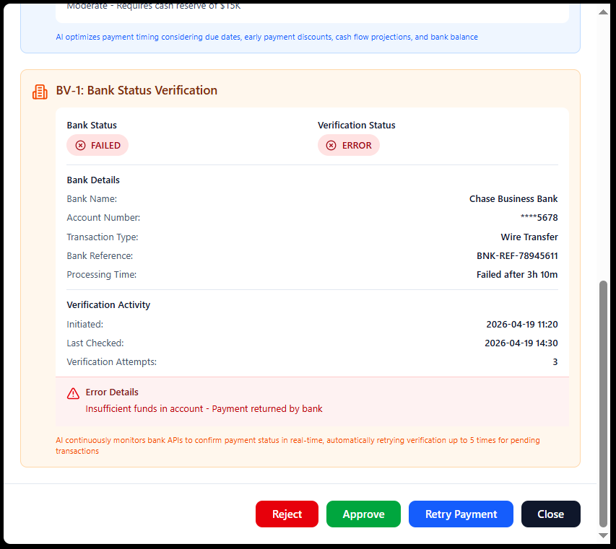

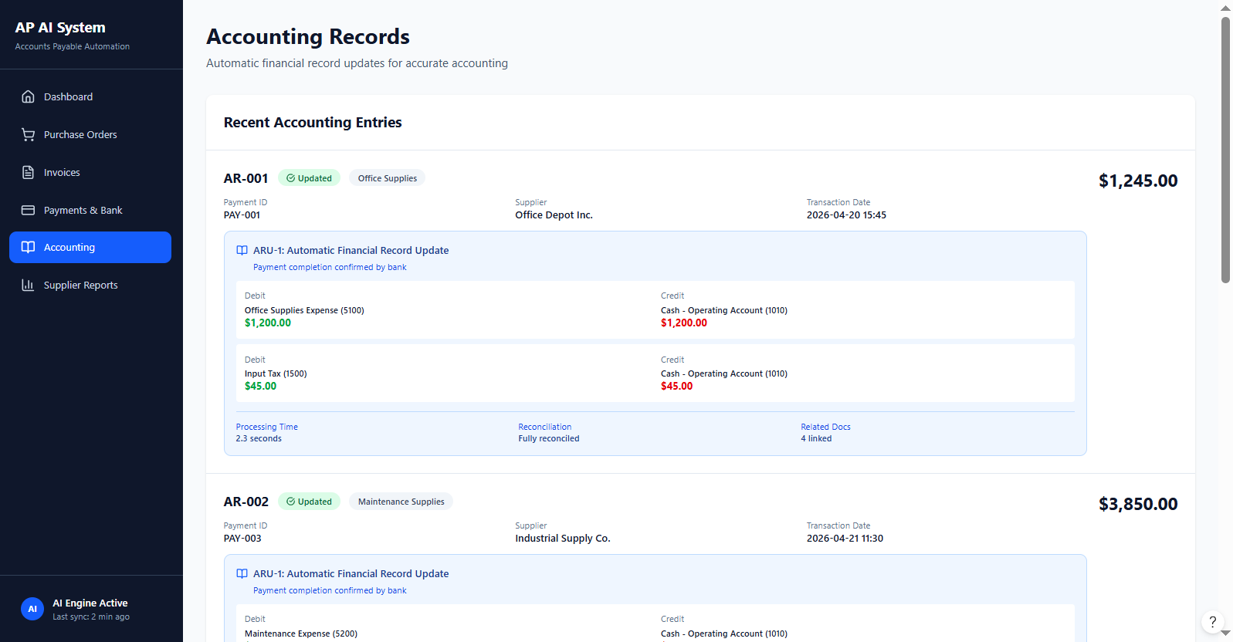

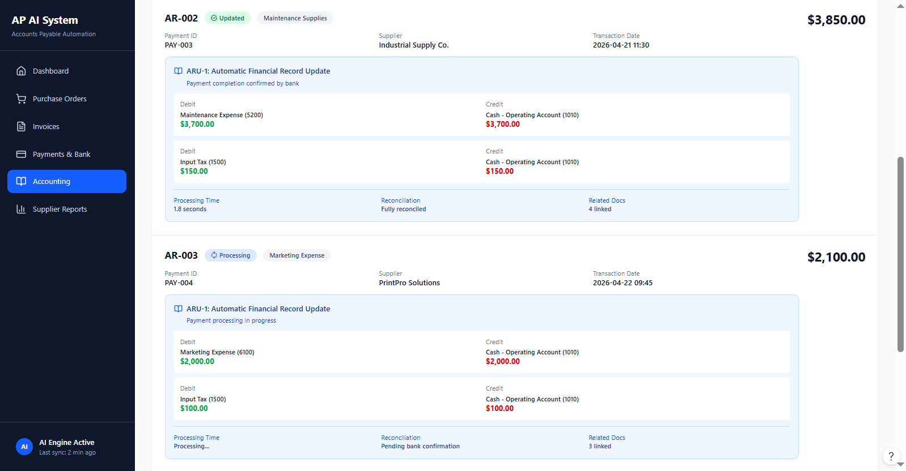

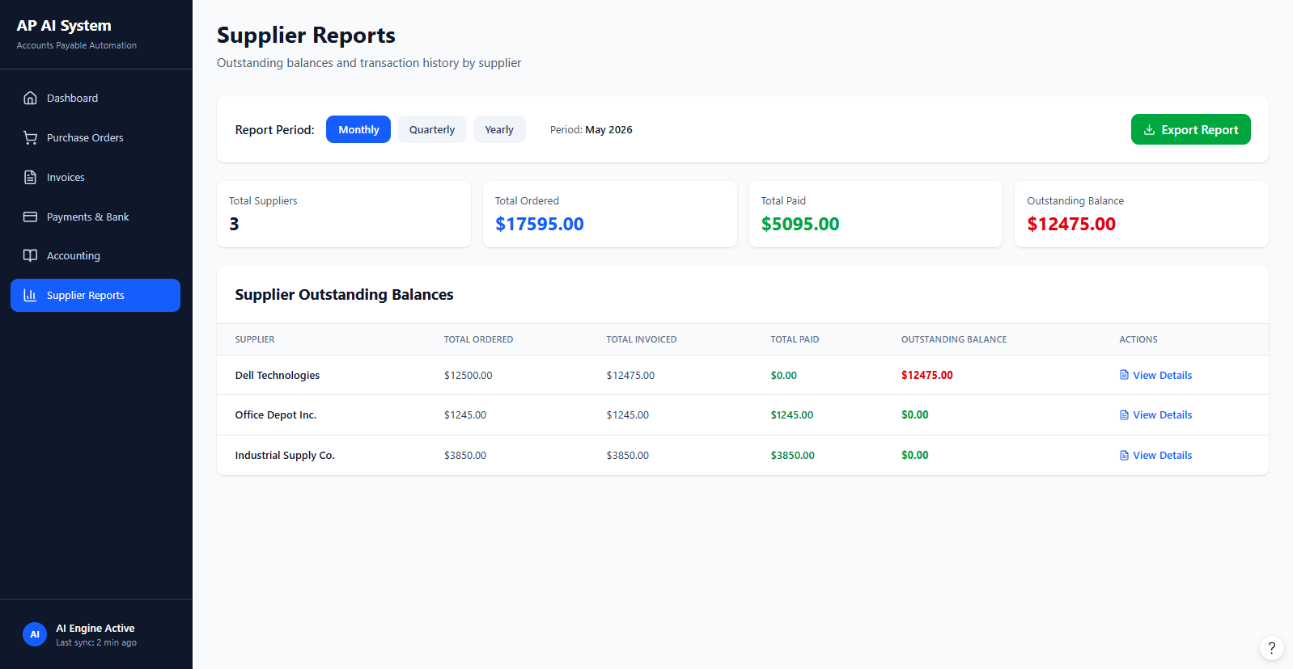

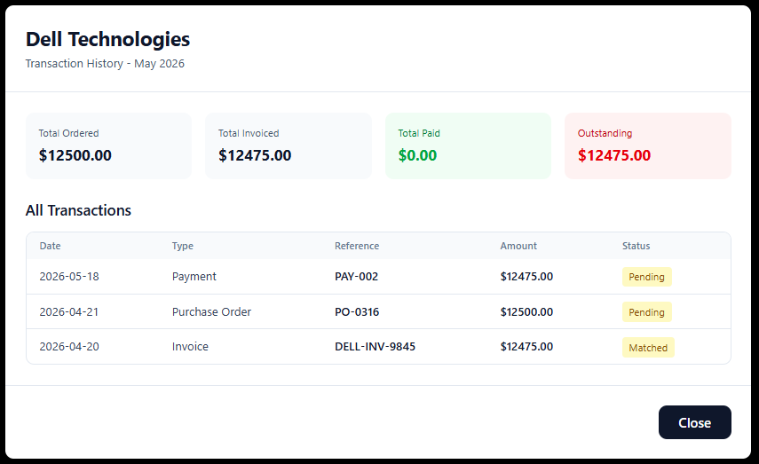

Test Cases

Test Case ID | User-Story ID | Test Scenario | Test Steps | Expected Results
TC-01 | IH-1 | Invoice missing key data. | PO numbers, amounts, suppliers, and items. No due date | Missing fields flagged.
TC-02 | IH-2 | Quantity differs from goods received | Quantity ordered = Dell XPS 15 (5 units), Quantity received = Dell XPS 15 (3 units) | Error flagged with details.
TC-03 | PP-1 | Require approval for high value payment | I f amount > 5000 must be approved first. Example: amount = 12,475 | The system re quires managerial approval.
TC-04 | PP-2 | Prevent duplicate scheduling | If payment id has 2 due dates Example :28/4/2026 and 29/4/2026 | The rejects system duplicates. Message: “Payment already scheduled”.

